|  |  |  |  |  |  |  |  |  |  |  |  |  |  |  |  |  |
| --- | --- | --- | --- | --- | --- | --- | --- | --- | --- | --- | --- | --- | --- | --- | --- | --- |
| L | C | S | T | G | S | C | R | F | S | S | N | D | F | C | U | F |
| C | Q | H | D | S | L | H | I | S | M | F | N | E | I | O | G | F |
| O | F | O | C | G | I | N | O | U | P | A | X | H | C | A | E | N |
| P | N | U | N | T | G | A | D | U | H | E | Q | N | E | K | L | H |
| P | O | D | U | E | T | N | W | B | L | T | L | I | W | N | F | B |
| W | R | E | R | J | A | H | E | N | D | D | E | C | Y | L | V | E |
| M | A | R | M | D | F | N | K | N | E | E | E | K | T | W | Y | G |
| X | T | Z | A | A | A | Y | C | G | R | S | W | R | O | E | I | N |
| J | U | E | S | P | I | L | J | L | I | A | H | C | O | L | E | O |
| E | H | E | E | R | S | T | R | O | E | A | Y | E | F | N | H | F |
| S | T | S | I | R | O | I | N | W | E | G | H | V | D | E | T | T |
| O | B | V | W | T | M | Q | X | Q | M | U | J | T | P | E | N | O |
| N | S | B | H | R | E | A | H | W | A | H | F | H | U | V | O | O |
| V | W | T | O | T | K | C | R | E | T | S | A | W | F | O | M | T |
| I | F | M | W | I | O | I | E | W | Q | D | F | Q | A | A | M | H |
| A | N | K | L | E | S | F | A | O | O | Y | U | M | P | R | C | H |
| J | Z | Q | F | T | I | H | R | T | R | E | G | N | E | F | L | E |

**Parts of the Body**

***Find the appropriate words of the pictures below in the Word-Search Puzzle and circle them:***

Word-Search Puzzle

**2**

**3**

**1**

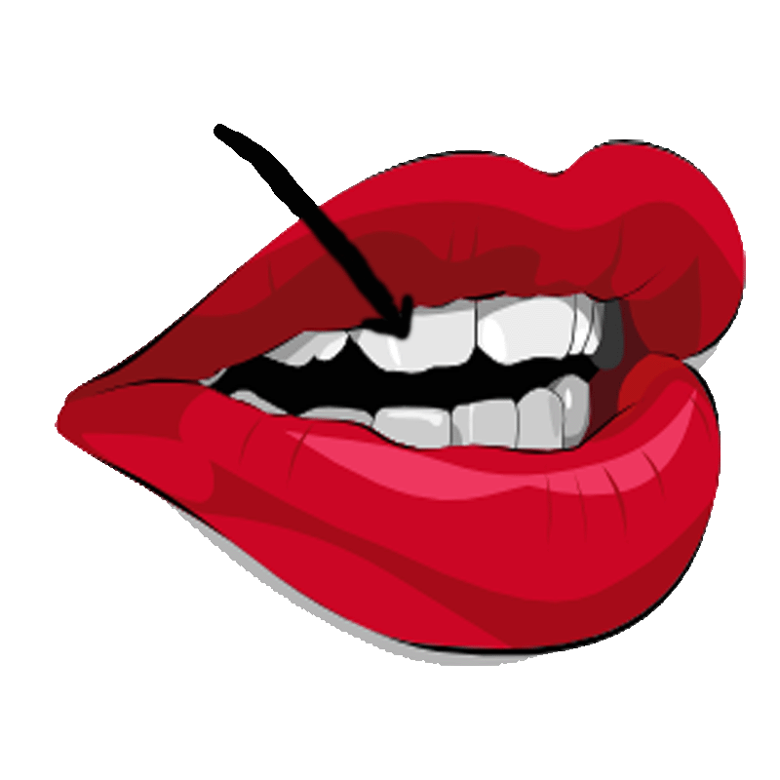

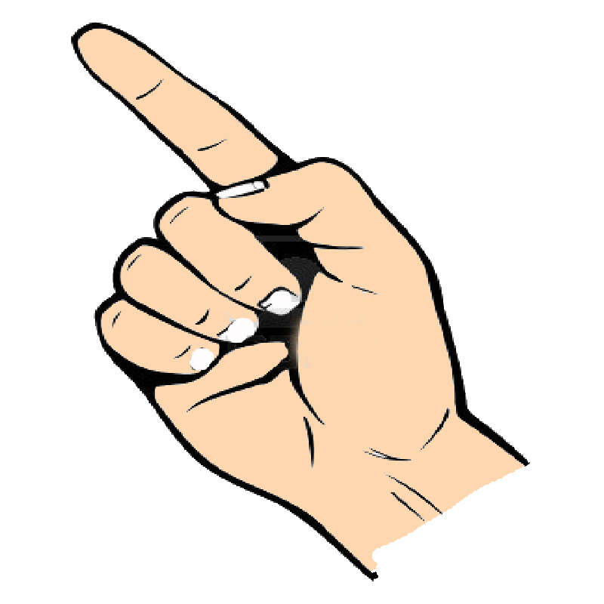

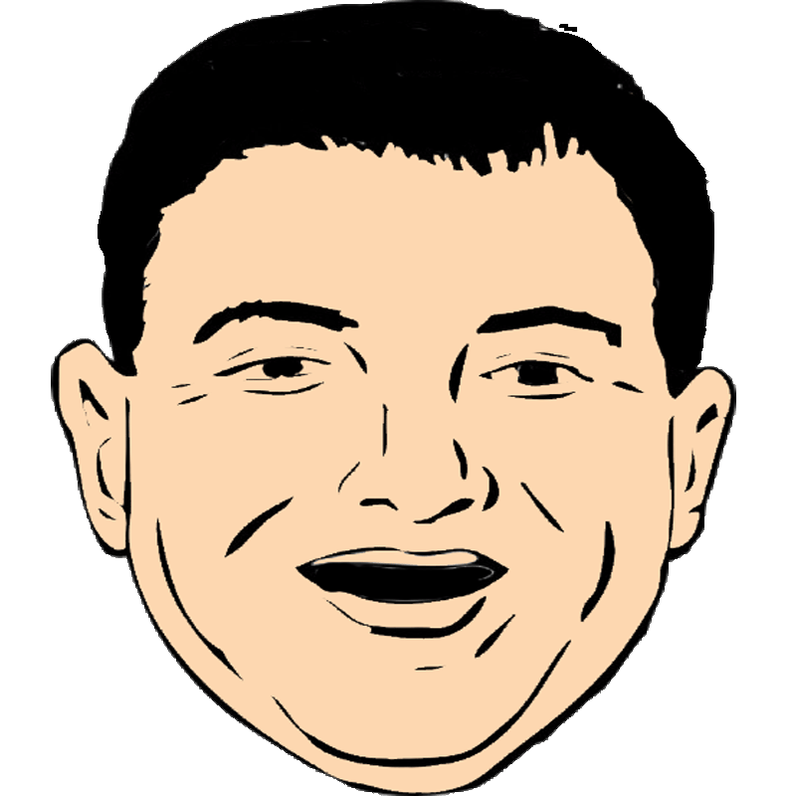

**5**

**6**

**4**

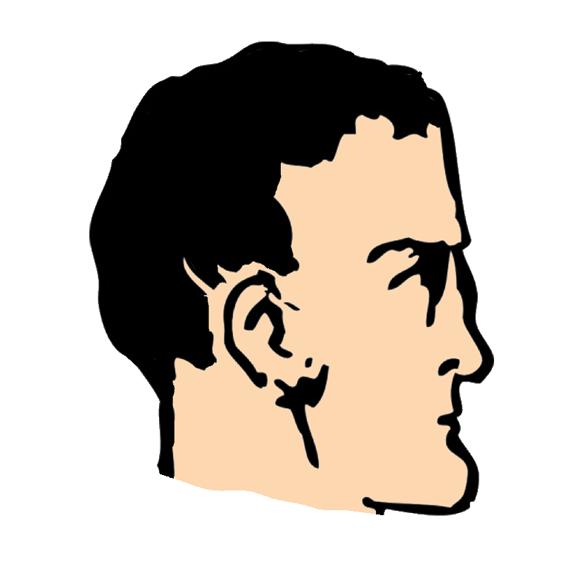

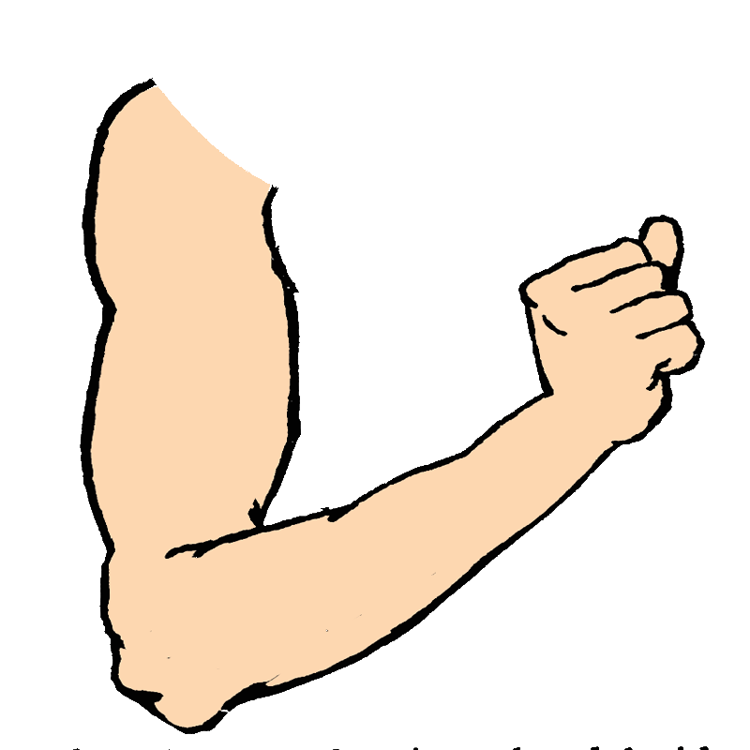

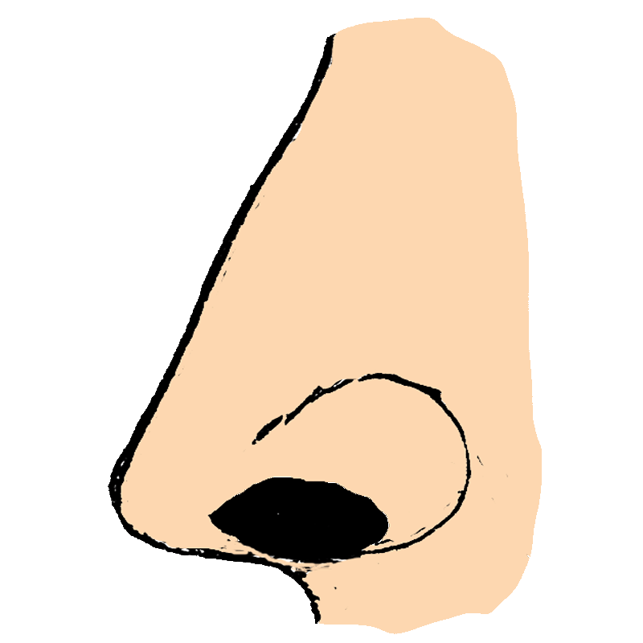

**9**

**8**

**7**

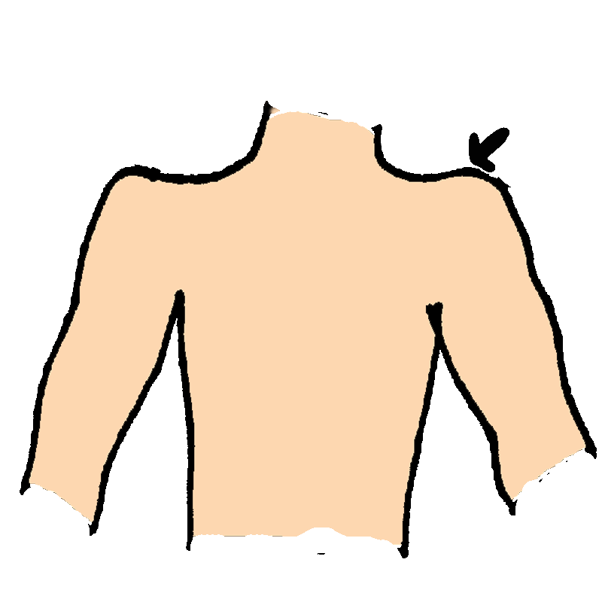

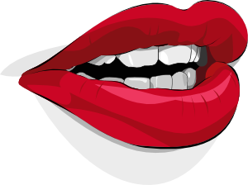

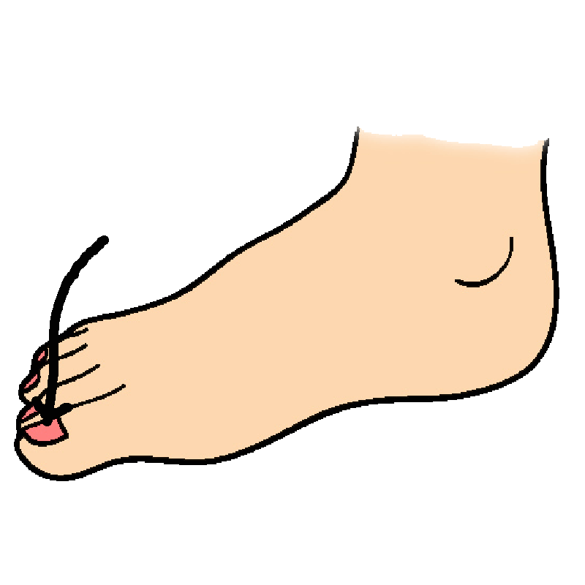

**12**

**11**

**10**

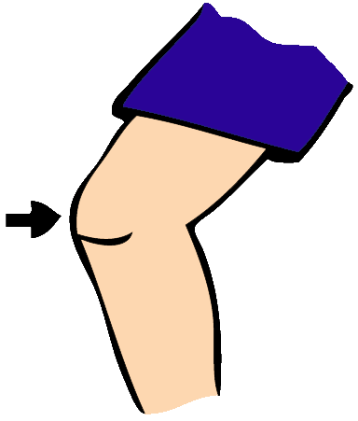

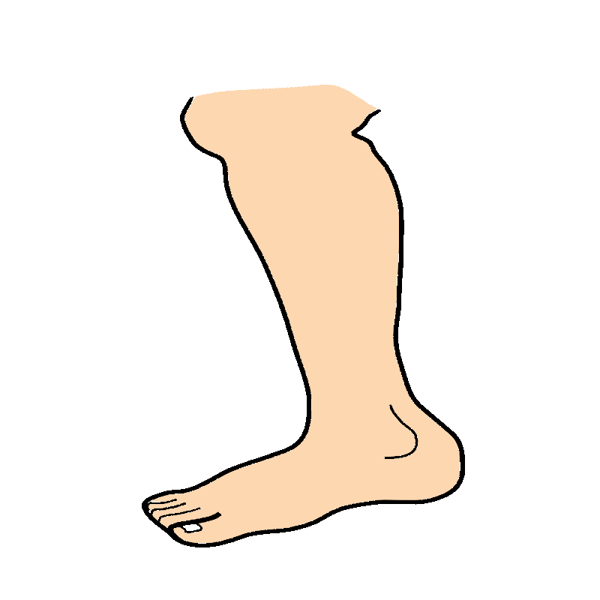

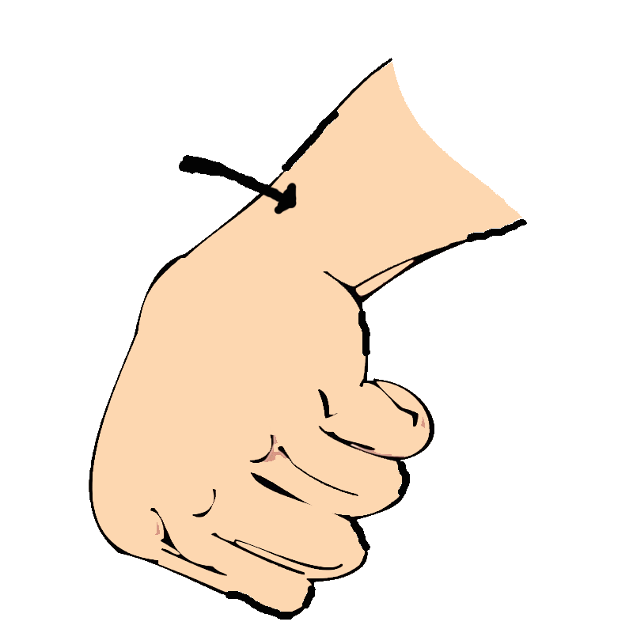

**14**

**15**

**13**

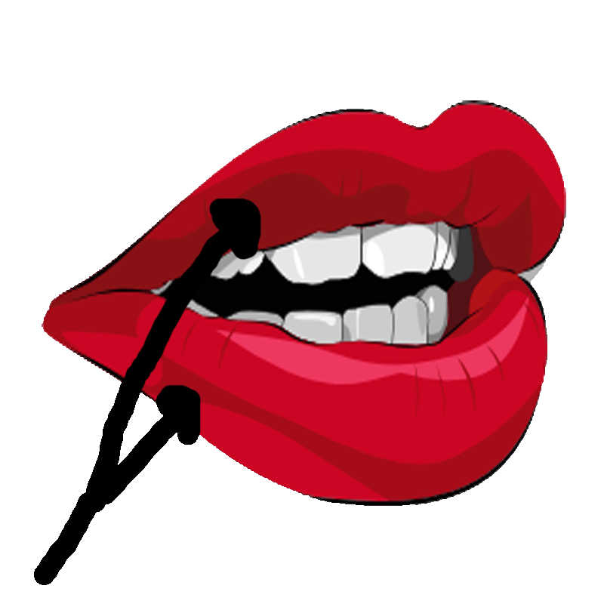

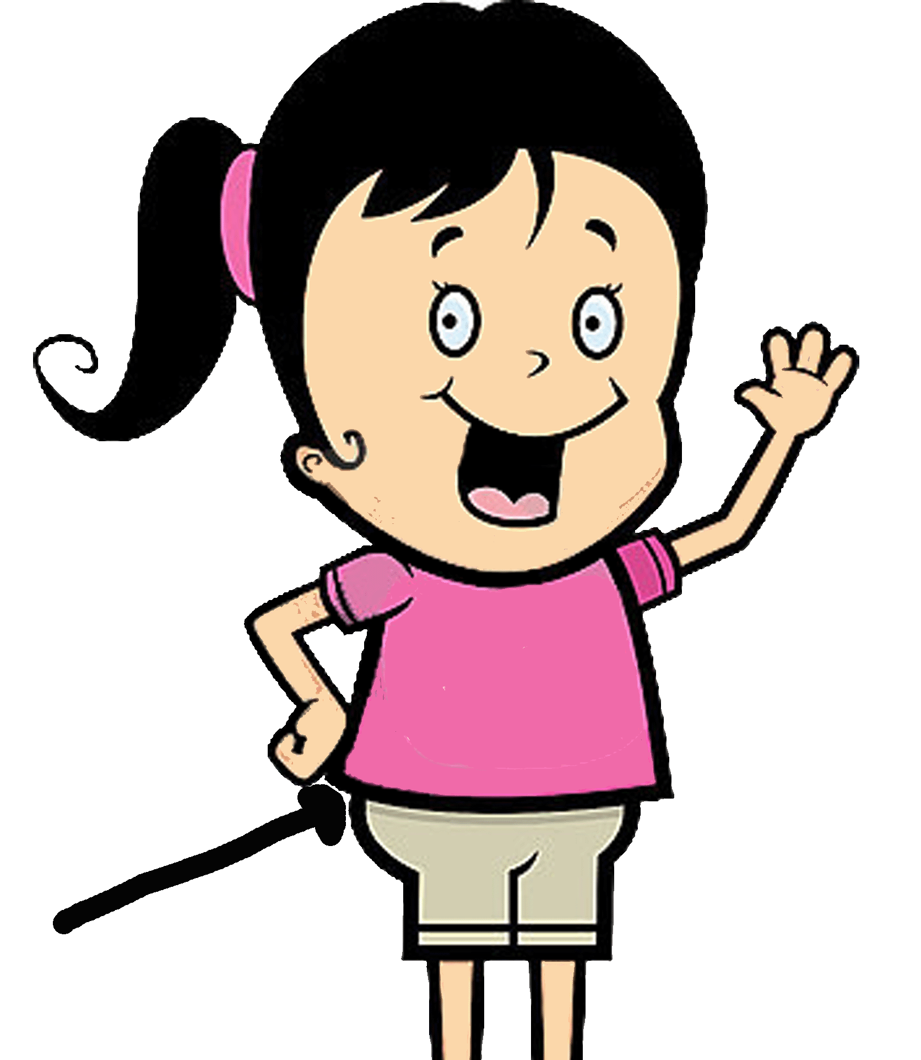

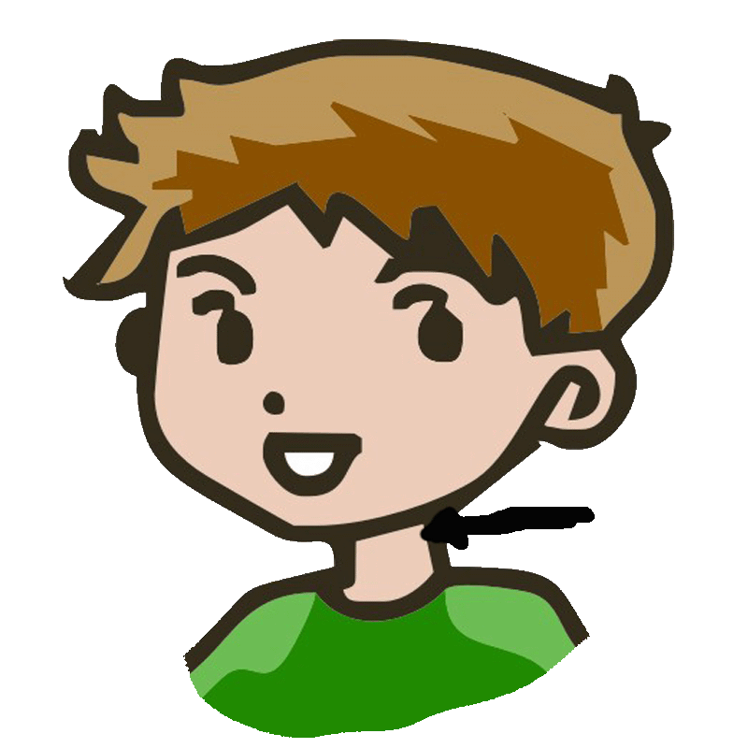

**18**

**17**

**16**

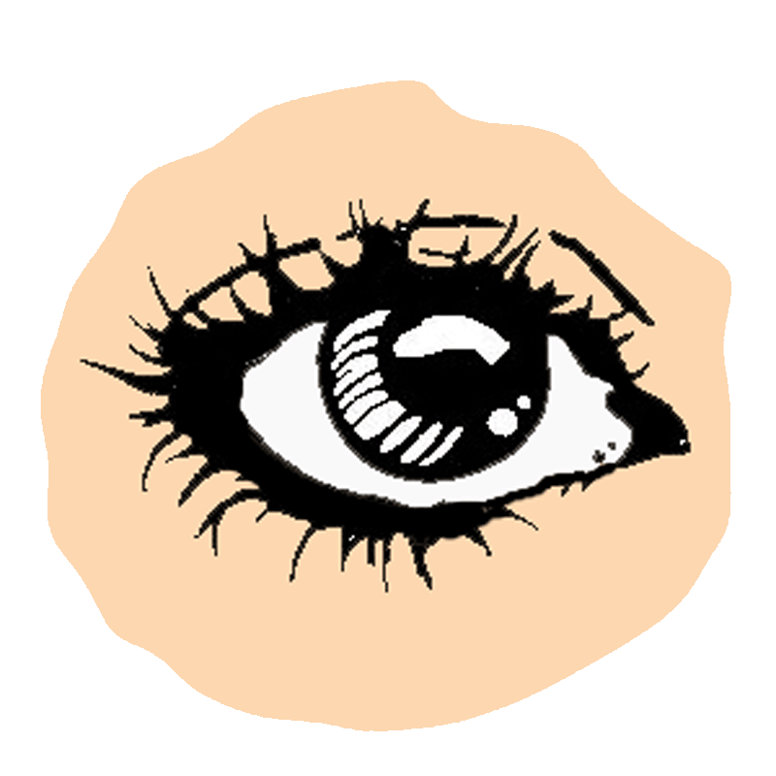

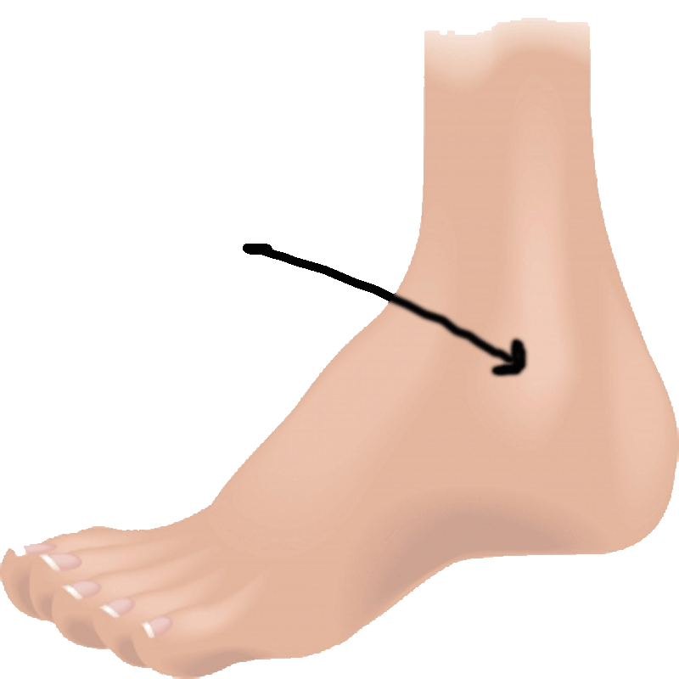

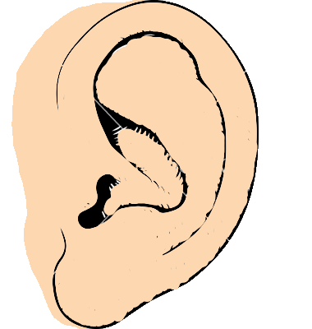

**20**

**19**

